DEALS TO BALTIMORE

Baltimore has a long history as a vital seaport and major city on the East Coast. Book a trip to Baltimore via Ronald Reagan National Airport or Washington Dulles International Airport on Virgin America. Live it up at 35,000 feet with WiFi, on-demand entertainment, and more on every flight.

(MARKET IMAGE HERE)

Find Deals From These Cities

INSERT FARE GRID FROM / TO Version (if available!)

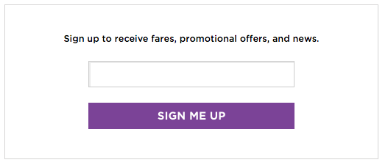

Top Things To Do in Baltimore

Wondering what to do in Baltimore, MD, other than catch an Orioles game? Plenty. From Little Italy and Federal Hill, to the Inner Harbor and Fells Point, there’s a diverse number of exciting attractions in Baltimore, MD. Here are a few of the top ones.

* Explore the Inner Harbor. Many Baltimore, MD attractions, including the National Aquarium and the Maryland Science Center, are located here. As you’re walking around, do some shopping, grab a bite to eat, and be entertained by some talented street performers.
* Visit Patterson Park. This 300-year old park is one of Baltimore’s oldest parks. It contains several remarkable features, including a marble fountain, swimming pool, and lake, and also hosts a variety of seasonal events and concerts. Don’t miss heading to the Pagoda atop Hampstead Hill for some magnificent panoramic views of the city.
* Spend some time in the historic and lively Federal Hill neighborhood. You’ll be able to see some of the best view’s of the Inner Harbor and have fun doing some antique shopping.
* Experience Italian culture in Little Italy. Catch an outdoor movie, watch a bocce tournament, and, of course, try delicious Italian food at one of the many restaurants in this neighborhood.
* Take a day trip to Provincetown, a quirky and well-loved town at the very tip of Cape Cod, and stroll along the narrow, cobble-stoned streets. This is a lively place with several restaurant and shopping options.

Travel Tips and Resources

[Must-Dos in Baltimore](http://www.travelchannel.com/destinations/us/md/baltimore/photos/best-of-baltimore)

[Baltimore Hotelshttp://www.tripadvisor.com/Hotels-g60811-Baltimore_Maryland-Hotels.html](http://www.tripadvisor.com/Hotels-g60811-Baltimore_Maryland-Hotels.html)

[Baltimore Restaurantshttp://www.tripadvisor.com/Restaurants-g60811-Baltimore_Maryland.html](http://www.tripadvisor.com/Restaurants-g60811-Baltimore_Maryland.html)

[Baltimore Shopping Guidehttp://www.10best.com/destinations/maryland/baltimore/shopping/shopping-centers-districts](http://www.10best.com/destinations/maryland/baltimore/shopping/shopping-centers-districts)

[Baltimore Nightlife and Entertainmenthttp://baltimore.org/dining-nightlife/nightlife](http://baltimore.org/dining-nightlife/nightlife)

[Baltimore Travel Tipshttp://travel.usnews.com/Baltimore_MD/Travel_Tips](http://travel.usnews.com/Baltimore_MD/Travel_Tips)

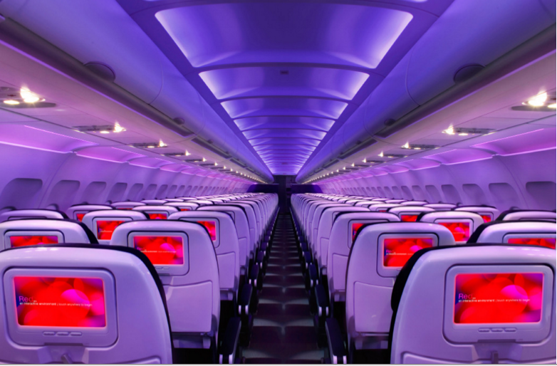

Main Cabin Main Cabin Select First Class

(add links to Cabin Class Pages)

Ready. Set. Fly.

Book your Mood-lit Ride to Baltimore.

When traveling to Baltimore, book your flight to Washington, D.C. with Virgin America. When you fly with us, you can choose to fly to one of two major airports. Both Ronald Reagan National Airport and Washington Dulles International Airport are just over an hour drive from Baltimore. On our flights, you’ll enjoy our sweet amenities, including our on-demand food ordering, in-flight WiFi, and mood-lit cabins. Make your time in the air an exceptionally pleasant one and fly with Virgin America.

Take a Virtual Tour

Add Terms & Conditions